**ML Classification Project: Performance Evaluation Results**

**Decision Tree Classifier**

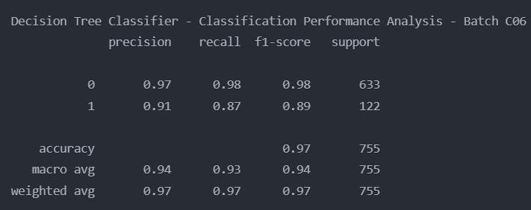

**Random Forest Classifier**

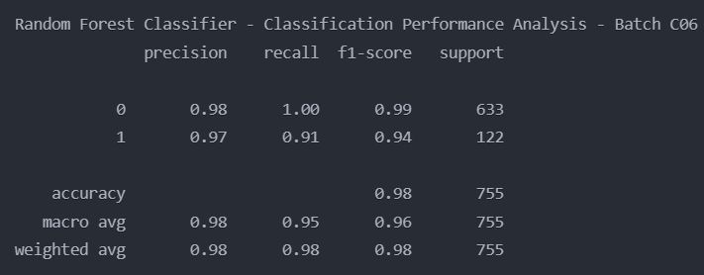

**SVM**

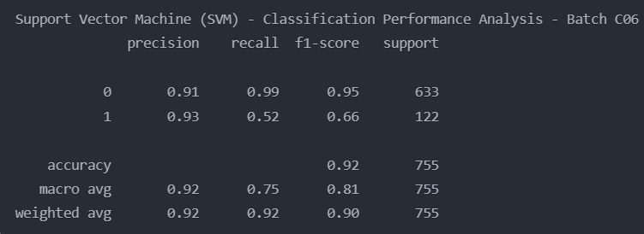

**Naive Bayes**

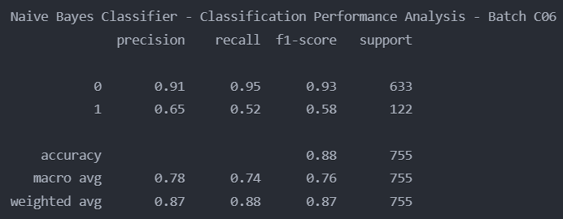

**XGBoost Classification**

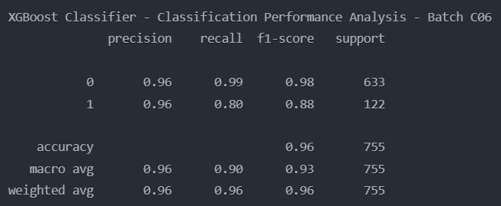

**Logistic Regression Classification**

